

# 

### Semester Two Examination, 2016

### Question/Answer Booklet

# MATHEMATICS

**SOLUTIONS**

**SPECIALIST**

**UNITS 1 AND 2**

## Section Two:

## Calculator-assumed

|  |  |  |  |  |  |  |  |  |
| --- | --- | --- | --- | --- | --- | --- | --- | --- |
| Student Number: In figures |  |  |  |  |  |  |  |  |

In words

Your name

## Time allowed for this section

Reading time before commencing work: ten minutes

Working time for section: one hundred minutes

## Materials required/recommended for this section

***To be provided by the supervisor***

This Question/Answer Booklet

Formula Sheet (retained from Section One)

***To be provided by the candidate***

Standard items: pens (blue/black preferred), pencils (including coloured), sharpener, correction fluid/tape, eraser, ruler, highlighters

Special items: drawing instruments, templates, notes on two unfolded sheets of A4 paper, and up to three calculators approved for use in the WACE examinations

## Important note to candidates

No other items may be taken into the examination room. It is **your** responsibility to ensure that you do not have any unauthorised notes or other items of a non-personal nature in the examination room. If you have any unauthorised material with you, hand it to the supervisor **before** reading any further.

## Structure of this paper

|  |  |  |  |  |  |
| --- | --- | --- | --- | --- | --- |
| Section | Number of questions available | Number of questions to be answered | Working  time (minutes) | Marks available | Percentage of exam |
| Section One:  Calculator-free | 7 | 7 | 50 | 51 | 35 |
| Section Two:  Calculator-assumed | 13 | 13 | 100 | 98 | 65 |
|  | | | **Total** | 149 | 100 |

## Instructions to candidates

1. The rules for the conduct of examinations are detailed in the school handbook. Sitting this examination implies that you agree to abide by these rules.

2. Write your answers in this Question/Answer Booklet.

3. You must be careful to confine your response to the specific question asked and to follow any instructions that are specified to a particular question.

4. Spare pages are included at the end of this booklet. They can be used for planning your responses and/or as additional space if required to continue an answer.

* Planning: If you use the spare pages for planning, indicate this clearly at the top of the page.
* Continuing an answer: If you need to use the space to continue an answer, indicate in the original answer space where the answer is continued, i.e. give the page number. Fill in the number of the question that you are continuing to answer at the top of the page.

5. **Show** **all your working clearly**. Your working should be in sufficient detail to allow your answers to be checked readily and for marks to be awarded for reasoning. Incorrect answers given without supporting reasoning cannot be allocated any marks. For any question or part question worth more than two marks, valid working or justification is required to receive full marks. If you repeat any question, ensure that you cancel the answer you do not wish to have marked.

6. It is recommended that you **do not use pencil**, except in diagrams.

7. The Formula Sheet is **not** to be handed in with your Question/Booklet.

Section Two: Calculator-assumed 65% (98 Marks)

This section has**thirteen (****13)** questions. Answer **all** questions. Write your answers in the spaces provided.

Working time for this section is 100 minutes.

Question 8 (5 marks)

Points B, C and E lie on the circle with diameter AOD as shown below. $∠ABC=115°$, $∠BAC=20°$ and $∠ACE=60°$.

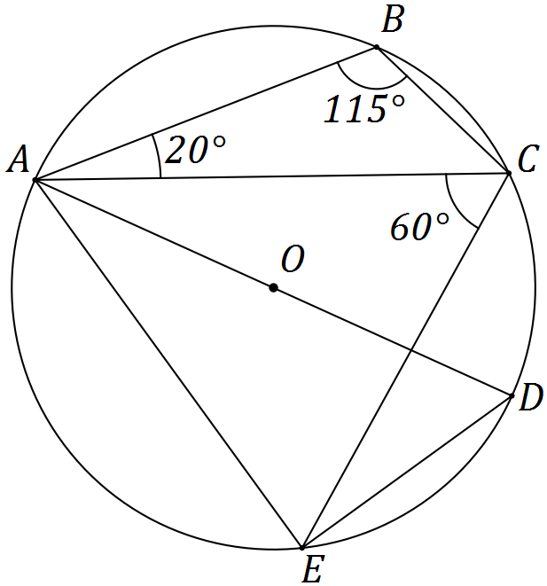

Determine the size of the following angles.

(a) $∠ADE$. (1 mark)

|  |
| --- |
| **Solution** |
| $60°$ |
| **Specific behaviours** |
| ✓ states angle |

(b) $∠EAD$. (1 mark)

|  |
| --- |
| **Solution** |
| $30°$ |
| **Specific behaviours** |
| ✓ states angle |

(c) $∠AEC$. (1 mark)

|  |
| --- |
| **Solution** |
| $65°$ |
| **Specific behaviours** |
| ✓ states angle |

(d) $∠CAD$. (1 mark)

|  |
| --- |
| **Solution** |
| $25°$ |
| **Specific behaviours** |
| ✓ states angle |

(e) $∠CED$. (1 mark)

|  |
| --- |
| **Solution** |
| $25°$ |
| **Specific behaviours** |
| ✓ states angle |

Question 9 (7 marks)

(a) $ABCDEF$ is a regular hexagon. The midpoint of side $DE$ is $M$.

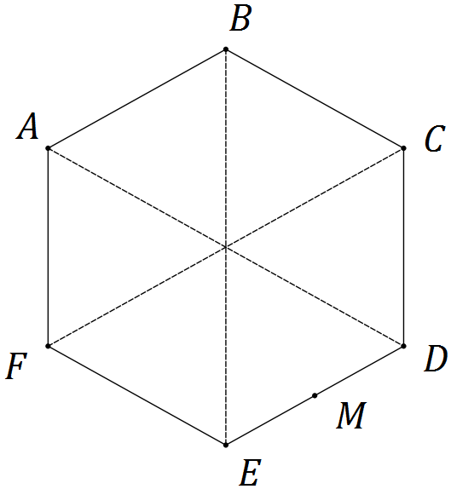

Let $a=\vec{AB}$ and $b=\vec{AF}$. Express each of the following in terms of a and b.

(i) $\vec{BC}$. (1 mark)

|  |
| --- |
| **Solution** |
| $\vec{BC}=a+b$ |
| **Specific behaviours** |
| ✓ states correct expression |

(ii) $\vec{AE}$. (1 mark)

|  |
| --- |
| **Solution** |
| $\vec{AE}=\vec{AF}+\vec{FE}=b+(a+b)=a+2b$ |
| **Specific behaviours** |
| ✓ states correct expression |

(iii) $\vec{MB}$. (1 mark)

|  |
| --- |
| **Solution** |
| $\vec{MB}=\vec{ME}+\vec{BE}=-0.5a-2b$ |
| **Specific behaviours** |
| ✓ states correct expression |

(b) Three forces, $F_{1}$, $F_{2}$ and $F_{3}$ act on a body that remains in equilibrium.

$F_{1}$ has a magnitude of 400 N. The angle between the directions of $F_{1}$ and $F_{2}$ is 150°, between $F_{1}$ and $F_{3}$ is 135° and between $F_{2}$ and $F_{3}$ is 75°.

Determine the magnitudes of $F_{2}$ and $F_{3}$, rounding your answers to the nearest whole number. (4 marks)

|  |
| --- |
| **Solution** |
| For equilibrium, $F_{1}+F_{2}+F_{3}=0$- nose to tail vectors in triangle.  If magnitudes of $F_{2}=x$ and $F_{3}=y$ then $\frac{x}{\sin{45}}=\frac{y}{\sin{30}}=\frac{400}{\sin{105}}$ Solving gives $x=F_{2}=293$ N and $y=F_{3}=207$ N. |
| **Specific behaviours** |
| ✓ sketch diagram  ✓ triangle or equation indicates force vectors must sum to zero  ✓ solves for  ✓ solves for $y$ |

Question 10 (7 marks)

(a) A number is to be formed by randomly selecting three **different** digits from those in the number 93265. Determine how many different numbers

(i) start with an odd digit. (1 mark)

|  |
| --- |
| **Solution** |
| $3×4×3=36$ numbers |
| **Specific behaviours** |
| ✓ calculates correct number |

(ii) end with an even digit. (1 mark)

|  |
| --- |
| **Solution** |
| $2×4×3=24$ numbers |
| **Specific behaviours** |
| ✓ calculates correct number |

(iii) start with an odd digit or end in an even digit. (2 marks)

|  |
| --- |
| **Solution** |
| $3×2×3=18$ numbers start with an odd digit and end in an even digit $36+24-18=42$ numbers |
| **Specific behaviours** |
| ✓ calculates set intersection  ✓ calculates correct number for set union |

(b) A computer user has forgotten their six character, case-sensitive password, but know that they always use a permutation of F, F, 1, 9, 9, and 9 - their initials and the year they were born. Determine how many passwords are possible if

(i) the F's must both be uppercase. (2 marks)

|  |
| --- |
| **Solution** |
| $\frac{6!}{2!×3!}=\frac{6×5×4}{2}=60$ passwords |
| **Specific behaviours** |
| ✓ shows correct method  ✓ calculates correct number |

(ii) either F can be lowercase or uppercase. (1 mark)

|  |
| --- |
| **Solution** |
| FF can be replaced with Ff, fF or ff, so $4×60=240$ passwords |
| **Specific behaviours** |
| ✓ calculates correct number |

Question 11 (8 marks)

(a) Triangle BCE is such that B, C and E lie on a circle with centre O and radius 29 cm. Diameter AD and chord CE intersect at F, so that $DF=8.5$ cm and $EF=25.5$ cm.

Determine the lengths OF, CF and BC. (5 marks)

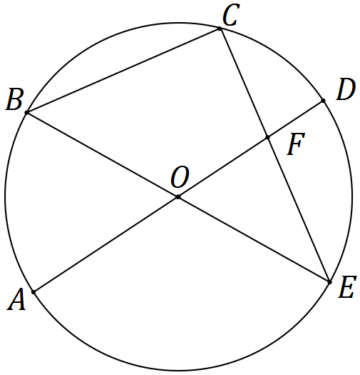

|  |
| --- |
| **Solution** |
| $OF=29-8.5=20.5$ cm $CF×EF=DF×AF⇒CF=8.5×\frac{29+20.5}{25.5}=16.5$ cm $ΔBCE$ is right-angled $⇒BC=\sqrt{{\left(29+29\right)}^{2}-{\left(16.5+25.5\right)}^{2}}=40$ cm |
| **Specific behaviours** |
| ✓ calculates OF  ✓ uses intersecting chord theorem  ✓ calculates CF  ✓ uses angle in semicircle  ✓ calculates BC |

(b) In the diagram below, points B, C and D lie on a circle with centre O. The tangents to the circle at B and D intersect at point A. If $∠BAD=x$, prove that $∠BCD=90°-\frac{x}{2}$. (3 marks)

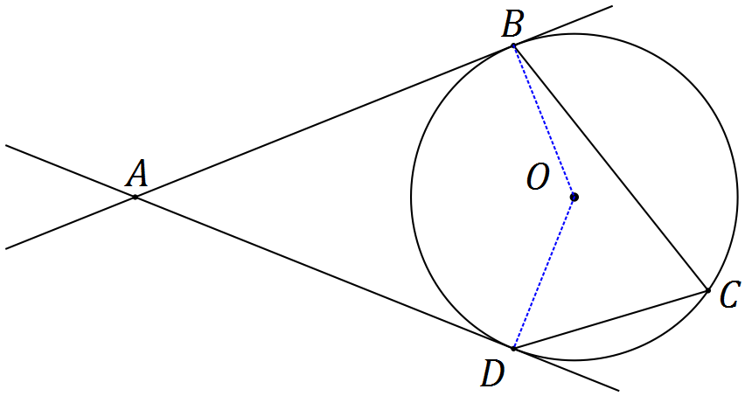

|  |
| --- |
| **Solution** |
| In quadrilateral ABOD, $∠ABO=∠ADO=90°$ (tangent-radius angle) $∠BOD=360-90-90-x=180-x$ (angle sum in quadrilateral) $∠BCD=\frac{1}{2}×∠BOD=\frac{1}{2}×180-x=90°-\frac{x}{2}$ (angle at centre twice that on circ.) |
| **Specific behaviours** |
| ✓ adds radii to diagram noting right-angles  ✓ determines $∠BOD$ with reason  ✓ determines $∠BCD$ with reason |

Question 12 (9 marks)

Transformation A is an anti-clockwise rotation about the origin of 90° and matrix $B=\left[\begin{matrix}2 & 0 \\ 0 & 3\end{matrix}\right]$.

(a) Represent transformation A as a $2×2$ matrix. (2 marks)

|  |
| --- |
| **Solution** |
| $$A=\left[\begin{matrix}0 & -1 \\ 1 & 0\end{matrix}\right]$$ |
| **Specific behaviours** |
| ✓ writes matrix for 90° rotation  ✓ matrix is for anticlockwise rotation |

(b) Describe the transformation represented by matrix B. (2 marks)

|  |
| --- |
| **Solution** |
| A dilation parallel to x-axis of scale factor 2 and dilation parallel to y-axis of scale factor 3. |
| **Specific behaviours** |
| ✓ two dilations  ✓ fully qualifies both dilations with directions and scale factors |

(c) Determine the coordinates of the point $P(-15, -11)$ following transformation A and then transformation B. (2 marks)

|  |
| --- |
| **Solution** |
| $$P^{'}=\left[\begin{matrix}2 & 0 \\ 0 & 3\end{matrix}\right]×\left[\begin{matrix}0 & -1 \\ 1 & 0\end{matrix}\right]×\left[\begin{matrix}-15 \\ -11\end{matrix}\right]$$ $$=\left[\begin{matrix}2 & 0 \\ 0 & 3\end{matrix}\right]×\left[\begin{matrix}11 \\ -15\end{matrix}\right]=\left[\begin{matrix}22 \\ -45\end{matrix}\right]$$ |
| **Specific behaviours** |
| ✓ calculates first image using A  ✓ calculates $P'$ |

(d) Following transformation B and then transformation A, point Q is transformed to point $Q'(12, 7)$.

Determine the single matrix that will transform $Q'$ back to $Q$ and hence determine the coordinates of point Q. (3 marks)

|  |
| --- |
| **Solution** |
| $$Q^{'}=ABQ⇒Q=B^{-1}A^{-1}Q' \\ B^{-1}A^{-1}=\left[\begin{matrix}\frac{1}{2} & 0 \\ 0 & \frac{1}{3}\end{matrix}\right]×\left[\begin{matrix}0 & 1 \\ -1 & 0\end{matrix}\right]=\left[\begin{matrix}0 & \frac{1}{2} \\ -\frac{1}{3} & 0\end{matrix}\right] \\ Q=\left[\begin{matrix}0 & \frac{1}{2} \\ -\frac{1}{3} & 0\end{matrix}\right]×\left[\begin{matrix}12 \\ 7\end{matrix}\right]=\left[\begin{matrix}3.5 \\ -4\end{matrix}\right]$$ |
| **Specific behaviours** |
| ✓ determines inverse of B and inverse of A  ✓ determines single matrix  ✓ determines coordinates of Q |

Question 13 (8 marks)

(a) On the axes below sketch the graph of $y=\frac{1}{2}\sec\left(x-\frac{π}{2}\right)$. (3 marks)

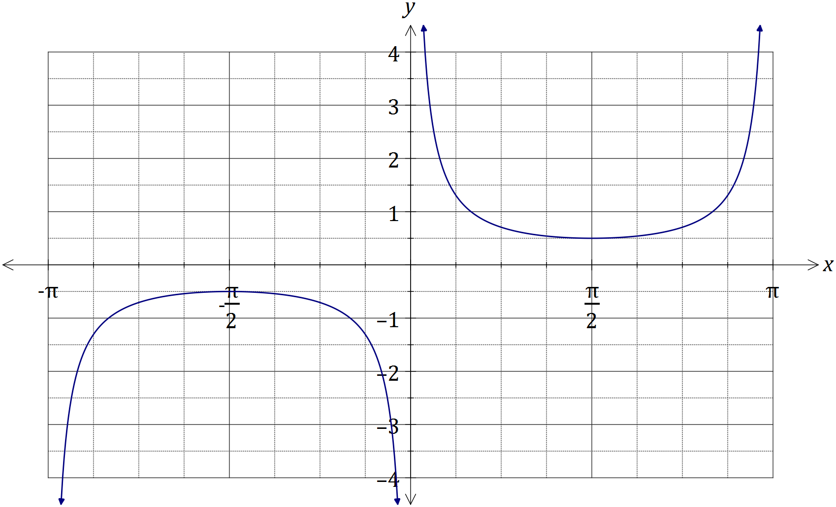

|  |
| --- |
| **Solution** |
| See graph |
| **Specific behaviours** |
| ✓ max/min correct locations  ✓ vertical asymptotes  ✓ smooth curves |

(b) Consider the function $f\left(t\right)=2\sin{t}-5\cos{t}$, $t≥0$.

(i) $f\left(t\right)$ can be expressed in the form $r\sin{(t-α)}$, where $r>0$ and $0≤α≤\frac{π}{2}$. Determine the values of $r$ and $α$, rounded to 2 decimal places. (3 marks)

|  |
| --- |
| **Solution** |
| $$2\sin{t}-5\cos{t}= r\sin{(t-α)} \\ =r\sin{t}\cos{α}-r\cos{t}\sin{α}$$ $r\cos{α}=2$ and $r\sin{α}=5$ $⇒r=\sqrt{29}≈5.39$, $α=\tan^{-1}{\frac{5}{2}}≈1.19$ |
| **Specific behaviours** |
| ✓ uses difference identity  ✓ determines r  ✓ determines $α$ |

(ii) Hence or otherwise determine the minimum value of $f(t)$ and the smallest value of t for this minimum to occur. (2 marks)

|  |
| --- |
| **Solution** |
| Minimum value is $-\sqrt{29}$ Occurs when $t-\tan^{-1}{\frac{5}{2}}=\frac{3π}{2}⇒t≈5.90$ |
| **Specific behaviours** |
| ✓ states minimum value  ✓ determines first time, $t≥0$ |

Question 14 (8 marks)

(a) Consider the vectors $p=(24, -143)$ and $q=(20, -21)$. Determine

(i) the angle between the directions of vectors p and q. (1 mark)

|  |
| --- |
| **Solution** |
| Using CAS, angle is 34.1° |
| **Specific behaviours** |
| ✓ states correct angle. |

(ii) two vectors that are perpendicular to q and have the same magnitude as p.

(3 marks)

|  |
| --- |
| **Solution** |
| Magnitude of required vectors are  Unit vectors $⊥$ to q are $±\frac{1}{29}\left(21, 20\right)$ Required vectors are $±\frac{145}{29}×\left(21, 20\right)=\left(105, 100\right)$ and $(-105, -100)$ |
| **Specific behaviours** |
| ✓ calculates magnitudes of p and q  ✓ determines at least one perpendicular vector  ✓ states both required vectors |

(b) If $\vec{AB}=(3, 4)$ and $\vec{AC}=(-2, 1)$, determine

(i) the component of $\vec{AB}$ parallel to $\vec{AC}$. (2 marks)

|  |
| --- |
| **Solution** |
| Vector projection of $\vec{AB}$ on $\vec{AC}$: $$\frac{\left(3, 4\right)⋅\left(-2, 1\right)}{\left(-2, 1\right)⋅\left(-2, 1\right)}×\left(-2, 1\right)=(0.8,-0.4)$$ |
| **Specific behaviours** |
| ✓ substitutes correctly into vector projection formula  ✓ evaluates component |

(ii) the component of $\vec{AB}$ perpendicular to $\vec{AC}$. (2 marks)

|  |
| --- |
| **Solution** |
| Let component be r. $$r+\left(0.8, -0.4\right)=\vec{AB} \\ r=\left(2.2, 4.4\right)$$ |
| **Specific behaviours** |
| ✓ shows use of vector addition  ✓ evaluates component |

Question 15 (8 marks)

(a) Express the recurring decimal $1.1\overline{58}$ as a rational number. (2 marks)

|  |
| --- |
| **Solution** |
| Let $x=1.158585858585…$ then $100x=115.858585858…$ So $100x-x=99x=114.7⇒x=\frac{1147}{990}$ |
| **Specific behaviours** |
| ✓ multiplies by 100  ✓ expresses as rational number in lowest terms |

(b) Use a counterexample to explain why the statement $(∀x∈Z)(∃y∈Z)(2xy=24)$ is false.

(2 marks)

|  |
| --- |
| **Solution** |
| If $x=24$, then $y=\frac{1}{2}$ and so statement is false, as an integer value for $y$ clearly does not exist for all values of $x$. |
| **Specific behaviours** |
| ✓ counterexample  ✓ explanation |

(c) Prove, by contradiction, that $\sqrt{6}$ is irrational. (4 marks)

|  |
| --- |
| **Solution** |
| Assume that $\sqrt{6}$ is rational and can be expressed in the form $\frac{a}{b}$ where a and b are both integers with no common factors.  Then 6 $=\frac{a^{2}}{b^{2}}⇒a^{2}=6b^{2}=2(3b^{2})$, so that $a^{2}$ and hence a must be even.  If $a=2k$ (k an integer) then ${\left(2k\right)}^{2}=6b^{2}⇒{3b}^{2}=2k^{2}$, so that $3b^{2}$ and hence $b^{2}$ and b must also be even.  But if both a and b are multiples of 2, this contradicts the original assumption, which means it is false and so $\sqrt{6}$ is not rational, and so must be irrational. |
| **Specific behaviours** |
| ✓ clearly makes rational assumption  ✓ deduces that a must be even  ✓ deduces that b must be even  ✓ explains contradiction |

Question 16 (7 marks)

(a) Let the angle $θ=\frac{π}{3}-\frac{π}{4}=\frac{π}{12}$.

(i) Use your calculator to write down an exact value for $\sin\left(\frac{π}{12}\right)$. (1 mark)

|  |
| --- |
| **Solution** |
| $\frac{\sqrt{2}\left(\sqrt{3}-1\right)}{4}=\frac{\sqrt{6}-\sqrt{2}}{4}$ |
| **Specific behaviours** |
| ✓ writes an exact value |

(ii) Use an angle sum or difference identity to show how to obtain the above exact value for $\sin\left(\frac{π}{12}\right)$. (3 marks)

|  |
| --- |
| **Solution** |
| $$\sin\left(\frac{π}{3}-\frac{π}{4}\right)=\sin\left(\frac{π}{3}\right)\cos\left(\frac{π}{4}\right)-\cos\left(\frac{π}{3}\right)\sin\left(\frac{π}{4}\right) \\ =\frac{\sqrt{3}}{2}×\frac{\sqrt{2}}{2}-\frac{1}{2}×\frac{\sqrt{2}}{2} \\ =\frac{\sqrt{6}-\sqrt{2}}{4}$$ |
| **Specific behaviours** |
| ✓ uses difference identity  ✓ shows substitution of four correct values  ✓ shows simplification |

(b) Prove the identity $\sin{x}+\sin{2x}+\sin{3x}=\left(1+2\cos{x}\right)\sin{2x}$. (3 marks)

|  |
| --- |
| **Solution** |
| $$RHS=\left(1+2\cos{x}\right)\sin{2x} \\ =\sin{2x}+2\sin{2x}\cos{x} \\ =\sin{2x +\sin\left(2x+x\right)+sin\left(2x-x\right)} \\ =\sin{x}+\sin{2x}+\sin{3x} \\ =LHS$$ |
| **Specific behaviours** |
| ✓ expands RHS  ✓ uses product as sum and difference  ✓ completes proof in logical steps |

Question 17 (9 marks)

Trapezium OPQR has parallel sides PQ and OR such that $\left|\vec{OR}\right|=k|\vec{PQ}|$. Let $\vec{OP}=a$ and $\vec{PQ}=b$.

(a) Sketch the trapezium. (1 mark)

|  |
| --- |
| **Solution** |
|  |
| **Specific behaviours** |
| ✓ draws labelled trapezium |

(b) Determine vectors for $\vec{OQ}$ and $\vec{PR}$ in terms of $k$, a and b. (2 marks)

|  |
| --- |
| **Solution** |
| $\vec{OQ}=a+b$ and $\vec{PR}=kb-a$. |
| **Specific behaviours** |
| ✓ states first vector  ✓ states second vector |

(c) Show that the scalar product of $\vec{OQ}$ and $\vec{PR}$ is $k{\left|b\right|}^{2}-{\left|a\right|}^{2}+\left(k-1\right)a⋅b$. (2 marks)

|  |
| --- |
| **Solution** |
|  |
| **Specific behaviours** |
| ✓ expands scalar product  ✓ simplifies scalar product |

(d) Simplify your result from (c) if $k=1$, $a=i+4j$ and $b=3i-2\sqrt{2}j$. (2 marks)

|  |
| --- |
| **Solution** |
|  |
| **Specific behaviours** |
| ✓ substitutes $k=1$ to eliminate  ✓ determines magnitudes and simplifies expression to zero |

(e) Explain the geometric significance of your result from (d). (2 marks)

|  |
| --- |
| **Solution** |
| The values of k, a and b have turned the trapezium into a rhombus and as the scalar product is zero, the diagonals must intersect at right angles. |
| **Specific behaviours** |
| ✓ identifies significance of values  ✓ uses scalar product to conclude that diagonals intersect at right angles |

Question 18 (7 marks)

(a) The work done, in joules, by a force F Newtons in changing the displacement of an object s metres is given by the scalar product of F and s. Calculate the work done when a force of 750 N moves an object a distance of 85 cm at an angle of 5° to the force.

(2 marks)

|  |
| --- |
| **Solution** |
| $750×0.85×\cos{5°}=635.1$ N |
| **Specific behaviours** |
| ✓ substitutes correct values into scalar product  ✓evaluates work done |

(b) A drone flies with a constant velocity and height above level ground, over which a wind blows from the north west at 3.5 metres per second. After 15 seconds, the drone reaches a point 85 metres on a bearing of 020° from where it was launched. Determine the velocity of the drone, giving its magnitude to two decimal places and bearing to the nearest degree. (5 marks)

|  |
| --- |
| **Solution** |
| Wind component is $15×3.5=52.5$ m $a^{2}={52.5}^{2}+{85}^{2}-2\left(52.5\right)\left(85\right)\cos{115}⇒a=117.2737$   Speed of drone is $117.2737÷15=7.82$ m/s (2dp). $\frac{52.5}{\sin{x}}=\frac{106.4211}{\sin{115}}⇒x=24°$ and so bearing is $020-24=356°$. |
| **Specific behaviours** |
| ✓ sketch displacement vector diagram  ✓ uses cosine rule to determine drone displacement  ✓ calculates drone speed  ✓ uses sine rule to determine angle  ✓ determines bearing |

Question 19 (8 marks)

(a) A high school has 5 male and 9 female volunteers from which to choose a debating team of 5 students. Determine the number of different teams that can be formed if

(i) there are no special requirements. (1 mark)

|  |
| --- |
| **Solution** |
| $\left(\begin{matrix}14 \\ 5\end{matrix}\right)=2002$ teams |
| **Specific behaviours** |
| ✓ evaluates correct number |

(ii) there must be a captain and a vice-captain. (2 marks)

|  |
| --- |
| **Solution** |
| $\left(\begin{matrix}14 \\ 1\end{matrix}\right)×\left(\begin{matrix}13 \\ 1\end{matrix}\right)×\left(\begin{matrix}12 \\ 3\end{matrix}\right)=40040$ teams |
| **Specific behaviours** |
| ✓ shows a suitable method  ✓ evaluates correct number |

(iii) there must be more females than males, but at least one male. (2 marks)

|  |
| --- |
| **Solution** |
| $\left(\begin{matrix}5 \\ 1\end{matrix}\right)×\left(\begin{matrix}9 \\ 4\end{matrix}\right)+\left(\begin{matrix}5 \\ 2\end{matrix}\right)×\left(\begin{matrix}9 \\ 3\end{matrix}\right)=1470$ teams |
| **Specific behaviours** |
| ✓ shows a suitable method  ✓ evaluates correct number |

(b) Determine how many **different** numbers must be selected from the first 25 positive integers to be certain that at least one of them will be twice the other. (3 marks)

|  |
| --- |
| **Solution** |
| Partition integers into pigeonholes, where double included if possible:  {1, 2}, {3, 6}, {4, 8}, {5, 10}, {7, 14}, {9, 18}, {11, 22}, {12, 24},  {13}, {15}, {16}, {17}, {19}, {20}, {21}, {23}, {25}.  *NB Other partitions possible.*  There are 17 partitions (pigeonholes) and so 18 numbers (pigeons) are required to ensure that at least one will be twice the other. |
| **Specific behaviours** |
| ✓ partitions most integers  ✓ systematically partitions all integers  ✓ applies pigeonhole principle to get correct number |

Question 20 (7 marks)

In the diagram below, the tangents from point A touch the circle at B and F. Point E lies on the major arc BF and D lies on BF so that $DE⊥BF$. Points C and G lie on AB and AF extended respectively such that $EC⊥AC$ and $EG⊥AG$.

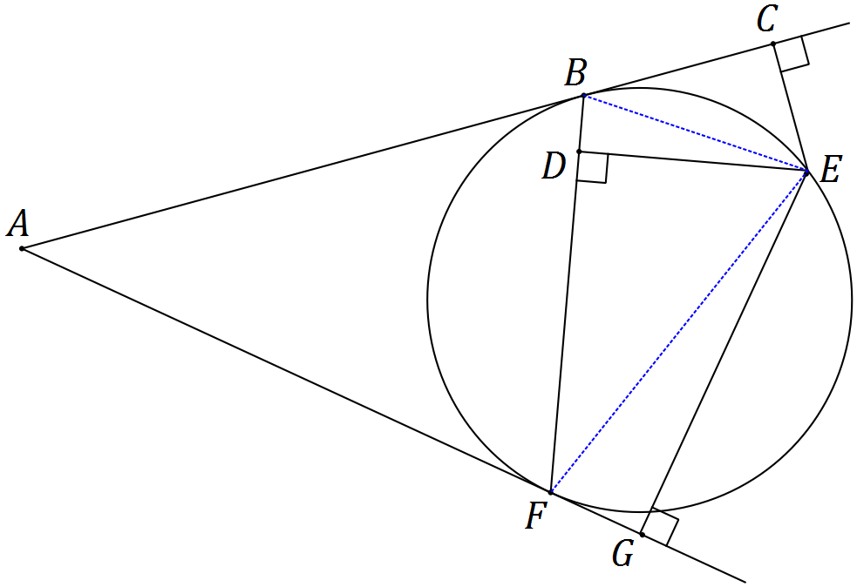

(a) Show that $ΔBCE$ and $ΔFDE$ are similar. (3 marks)

|  |
| --- |
| **Solution** |
| $∠CBE=∠DFE$ (alternate segment theorem) $∠BCE=∠FDE$ (both right)  Hence $ΔBCE∼ΔFDE$ (AA) |
| **Specific behaviours** |
| ✓ shows one pair of angles equal with reason  ✓ shows second pair of angles equal with reason  ✓ makes conclusion that similar |

(b) Show that $DE^{2}=CE×GE$. (4 marks)

|  |
| --- |
| **Solution** |
| $∠GFE=∠DBE$ (alternate segment theorem) $∠BDE=∠FGE$ (both right)  Hence $ΔBDE∼ΔFGE$ (AA)  So ratio of sides is $\frac{DE}{GE}=\frac{BE}{FE}$ But ratio of sides from (a) is $\frac{CE}{DE}=\frac{BE}{FE}⇒\frac{CE}{DE}=\frac{DE}{GE}⇒DE^{2}=CE×GE$. |
| **Specific behaviours** |
| ✓ realises second pair of similar triangles required  ✓ uses same reasoning from (a) to show  ✓ states ratio of corresponding sides for both pairs of triangles  ✓ uses common ratio to obtain result |

Additional working space

Question number: _________

© 2016 WA Exam Papers. Narrogin Senior High School has a non-exclusive licence to copy and communicate this paper for non-commercial, educational use within the school. No other copying, communication or use is permitted without the express written permission of WA Exam Papers.